**Bool Data type in solidity:**

In Solidity, the **bool** data type is used to represent boolean values, which can have one of two possible states: **true** or **false**. Boolean values are often used in conditional statements, logical operations, and to control the flow of a smart contract's execution.

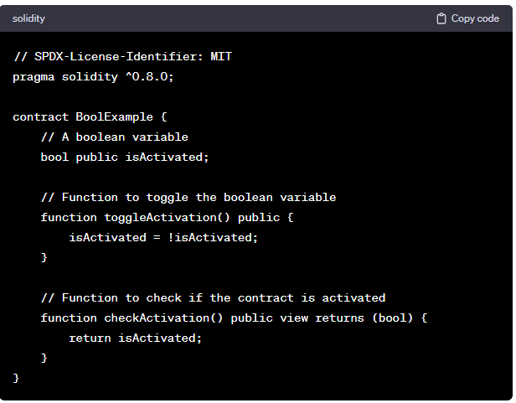

Boolean values are commonly used to control the logic and behavior of smart contracts. They are integral to conditional statements, loop control, and other decision-making constructs in Solidity.

**Booleans:**

1. Bool: The possible values are constants true and false.

**Operators:**

1. !(logical negation)
2. && (logical conjunction, “and”)
3. || (logical disjunction, “or”)
4. == (equality)
5. != (inequality)

**Code:**

//SPDX-License-Identifier: GPL-3.0

pragma solidity ^0.8.0;

contract Array{

    bool public value=true;

    function check(uint a) public returns(bool)

    {

        if(a>100)

        {

            value=true;

            return value;

        }

        else

        {

            value=false;

            return value;

        }

    }

}

**Output**

